Micro-services

We will create micro-service(µs)

* Language - Java
* Framework - Springboot

Java frameworks are pre-written code libraries and tools that provide a structure for building applications, simplifying development by offering reusable components and best practices. They help developers focus on application-specific logic instead of reinventing common functionalities.

What are Java Frameworks?

Pre-written code:  
Java frameworks are essentially collections of pre-written Java code, including classes, interfaces, and methods, that developers can use as a base for their projects.

Structure and guidance:  
They provide a structured environment for building applications, often enforcing specific design patterns and coding conventions.

Reusable components:  
Frameworks offer reusable components and libraries that handle common tasks like database interactions, web application logic, and testing, reducing the need for manual coding.

Increased productivity:  
By providing ready-made solutions, frameworks can significantly improve development time and efficiency.

Common Types of Java Frameworks:

Web Frameworks:  
These frameworks help in building web applications and include functionalities for handling requests, managing sessions, and rendering user interfaces, such as Spring MVC, Struts, and JSF (JavaServer Faces).

ORM (Object-Relational Mapping) Frameworks:  
ORM frameworks simplify database interactions by mapping Java objects to database tables, including Hibernate and JPA.

Testing Frameworks:  
These frameworks provide a structured way to write and execute tests, including JUnit, TestNG, and Mockito.

Microservices Frameworks:  
Frameworks like Spring Cloud and Micronaut are designed to facilitate the creation of microservices, modular and loosely coupled applications.

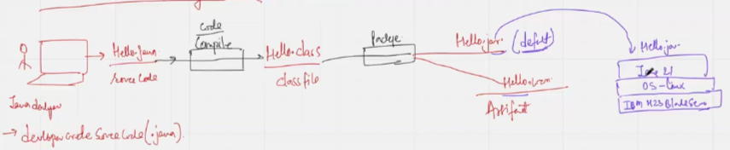

Application created in any programming language will run on server, it is a physical or virtual in nature

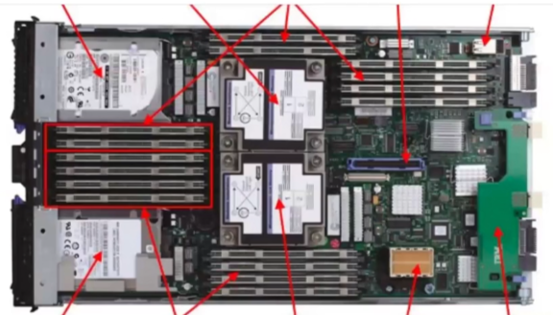

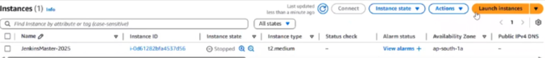

General knowledge of IT:

Infrastructure → Server → DB → Network → Storage

Real-world similarity

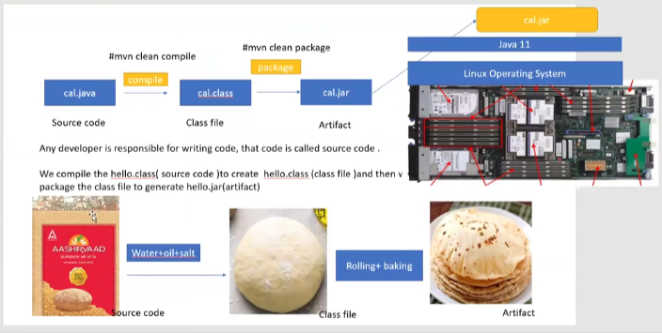

Steps to create an application:

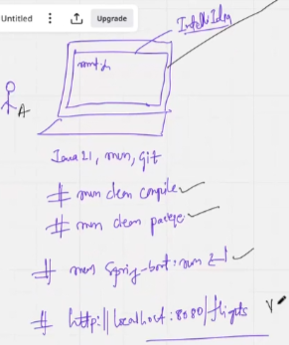

Looking at the code available on the local host one can ensure availability but company requires GIT for working with source code hence we call GIT shared REMOTE source code repository

